Refugee Sector Letter Blitz
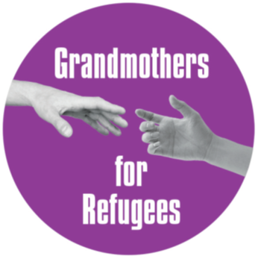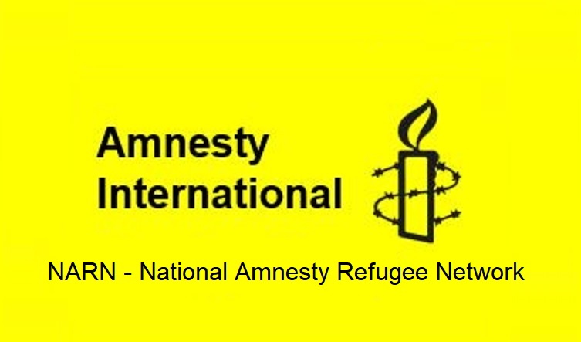

Urgent Action:
COVID19 Outbreak in Park Hotel, Melbourne
Supported by ARAN, RAR, G4R, & NARN

Included in this kit is the information you need to create your own letters:

- Guide and Background notes prepared by ARAN’s Letter Writing Network.
- Sample letter to Home Affairs Minister Andrews, to personalise and email.
- Sample letter to Victorian Health Minister
- Sample letter to ABC 7:30
- Link for email addresses for all MPs and Senators

NOTE: When you send an email be sure to include your NAME and ADDRESS

The Subject line of your email could be - CALL TO ACTION: Covid Outbreak in Immigration Detention

Personalised letters are best.

~~~~~~~~~~~~~~~~~~~~~~~~~~~~~~~~~~~~~
Regards,
The ARAN Letter Writing Network
austrefugeenetwork@gmail.com

Background Information for: COVID19 OUTBREAK AT PARK HOTEL, MELBOURNE
- 21 of the 46 refugees being held in the Park Hotel Melbourne have tested positive to Covid. Others are awaiting test results. Those who have tested positive are being held in isolation on one floor of the hotel.
- One other detainee is in hospital with severe COVID symptoms.
- The Park Hotel is unsuitable as quarantine accommodation. It is the former Rydges on Swanston Hotel, which was the source of 90% of Melbourne’s second COVID outbreak in 2020, and was deemed unsuitable by Victorian health officials to continue to be used for quarantine. See news report here.
- When Australian Border Force (ABF) took over the hotel for use as immigration detention, it had the windows sealed shut so they cannot be opened. The detainees have no access to fresh air ventilation. Air is re-circulated through the hotel’s air conditioning system. Sleeping and kitchen areas and the elevator are used communally.
- Because of the inadequate conditions, the detainees at the Park Hotel are at high risk of getting Covid. The men have existing health conditions, making them extremely vulnerable to COVID infection.
- The first COVID vaccinations in Australia began in February 2021. The people in immigration detention were not offered vaccinations until August, even though there had been exposures in detention centres well before that.
- Refugees inside the hotel have been expressing concerns about lack of attention to Covid-safe practices since early in the pandemic.
- The Morrison government has been fully aware of the heightened risk since March 2020. It has been warned repeatedly by experts that unnecessarily holding people in immigration detention puts the health of the detainees, staff and the broader community at risk.
- Many other countries responded to this risk by reducing the number of people held in detention. In contrast, the number of people in immigration in Australia has increased since the beginning of the pandemic.
- The Australian government is obliged to provide a safe environment for people in its care, but it has failed to do so. Continued detention is putting the men in Park Hotel at unnecessary risk to their life and long term health.
For further background see, for instance, here, here, here.
Key Requests:

- That all of the men be immediately evacuated from the Park Hotel, and
  - those who are Covid positive be moved to a suitable quarantine hotel with appropriate medical care and monitoring;
  - those who are Covid-free be moved to other suitable accommodation in the community and subject to regular COVID testing.

- That all ABF workers dealing with these men are required to be fully vaccinated and understand their obligations to work in Covid-safe ways.
Sample email to the Minister for Home Affairs Karen.Andrews.MP@aph.gov.au Phone (02) 6277 4360
- Copy your email to local ACT region MPs : senator.katy.gallagher@aph.gov.au senator.seselja@aph.gov.au Andrew.Leigh.MP@aph.gov.au Alicia.Payne.MP@aph.gov.au David.Smith.MP@aph.gov.au Kristy.McBain.MP@aph.gov.au
- Or Email addresses for all MPs and Senators
Dear Minister Andrews
I urge you to protect the refugees being held in the Park Hotel in Carlton from further infection and illness. As you well know, at least 21 men have now tested positive, one of whom has been hospitalised, and the remaining men are at extreme risk of contracting the virus. This type of outbreak in places of detention has long been feared. It is a sad irony that this is occurring in the Park Hotel – a key site in Victoria’s hotel quarantine crisis in 2020 – the hotel was then deemed as being highly unsuitable for quarantine, and more dedicated hotels have since been set up to provide safe quarantine. See news report here.
Health experts have long warned that immigration detention centres and APODs are high risk for Covid-safe infection. We now know that in addition to Park Hotel, units in MITA are locked down due to Covid exposure from staff.
While some of the men are fully vaccinated we know that some have been reluctant to be vaccinated, as a kind of insurance against being sent to Nauru as only fully vaccinated people can be sent to Nauru Such is the perversity of your deterrence based policies which provide only options which are damaging to health and well-being – while also denying the fundamental right to freedom.
Given the serious risk of illness and possible death for those exposed to Covid, especially those who have compromised health (as many of these men do), I urge you to ensure that:
- All of the men be immediately moved from the Park Hotel, and that
  - those who are Covid positive be moved to a Covid-safe quarantine hotel with appropriate medical care and monitoring
  - those who are Covid-free to be moved to other suitable accommodation in the community and provided regular testing for Covid – this could be some form of community detention.
  - ensure that all ABF workers dealing with these men are fully vaccinated and understand their obligations to work in Covid-safe ways
We cannot stand by and allow these men to become seriously ill, and others to contract Covid when we have the means to prevent this.
Please act urgently – use your power for good and make the necessary arrangements for the safety of these men.
Yours faithfully
your name
Address
Draft email to the Victorian Minister for Health, Premier and the Chief Health Officer.
Send an email to urge the Victoria Government to demand proper care and quarantine arrangements for these men.
Victorian Minister for Health martin.foley@parliament.vic.gov.au Phone 03 9096 7500
CC your email to: Premier of Victoria Daniel Andrews daniel.andrews@parliament.vic.gov.au
Chief Health Officer Dr Brett Sutton officeofcho@health.vic.gov.au
Dear Minister Foley
I urge you to demand action to protect the refugees being held in the Park Hotel in Carlton from further infection and illness. As you know, at least 20 men have tested positive, one of whom has been hospitalised, and the remaining men (more than 20) are at extreme risk of contracting the virus. This type of outbreak in places of detention has long been feared. It is a sad irony that this is occurring in the Park Hotel – a key site in Victoria’s hotel quarantine crisis in 2020 – the hotel was then deemed as being highly unsuitable for quarantine, and more dedicated hotels have since been set up to provide safe quarantine. See news report here.
Despite the high risk of infection, with the daily movements in and out of security and other staff, men have been held in the hotel since early in 2021 when Home Affairs established the hotel as an Alternative Place of Detention. Refugees inside the hotel have been expressing concerns for many months about lack of attention to Covid-safe practices. We know the hotel is now particularly dangerous as many of the men have tested positive. While some of the men are fully vaccinated we know that some have been reluctant to be vaccinated, as a kind of insurance against being sent to Nauru as only fully vaccinated people can be sent to Nauru - such is the perversity of a deterrence based policy.
Given the serious risk of illness and possible death for those exposed to Covid, especially those who have compromised health (as many of these men do), I urge you to use your public health powers to require that:
- All of the men be immediately moved from the Park Hotel, and that
  - those who are Covid positive be moved to a suitable quarantine hotel with appropriate medical care and monitoring
  - those who are Covid-free to be moved to other suitable accommodation in the community – this could be some form of community detention – and subject to regular testing.
  - Ensure that all ABF workers dealing with these men are fully vaccinated and understand their obligations to work in Covid-safe ways
We cannot stand by and allow more of these men to become Covid positive when we have the means to prevent this. Please act urgently to work with the Department of Home Affairs make suitable arrangements. Home Affairs Minister Andrews has total discretion, and can make appropriate decisions in an instant.
Yours faithfully
(your name)
Address
It would also be good to provide feedback to the ABC, and encourage them to continue coverage.
Sample letter to ABC
I was very heartened to see the 7.30 Report coverage of this terrible (and entirely avoidable) situation. I am gravely concerned for the well being of all those men held, and the immediate risk from Covid.
I hope the ABC will continue to cover this story - these men have been 'imprisoned' in our midst for nearly 2 years - and before that offshore on Nauru or PNG for more than 6 years.
Amnesty International lobbies other governments for the release of people detained arbitrarily - it is outrageous that our government is perpetrating the same injustices, and few Australians seem to know.
I understand there is also Covid exposure at the Immigration Detention Centre in Broadmeadows. Perhaps you could do a follow-up story with Graham Thom (Amnesty), Ian Rintoul (Refugee Action Coalition - mailto:rintoulian10@gmail.com, Doctors for Refugees https://www.doctors4refugees.org/ and Human Rights Watch.
We must do all we can for the safety of these men - thank you

