Refugee Sector Letter Blitz
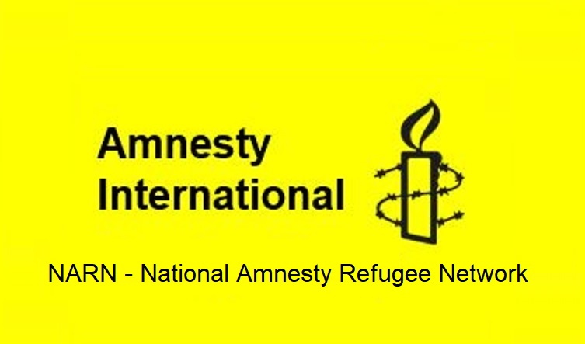

Issue for Dec 2021:
Increase the Afghan refugee intake to 20,000 Supported by ARAN, RAR, G4R, & NARN

Available to download at - https://www.ruralaustraliansforrefugees.org.au/rar-groups/online-group/

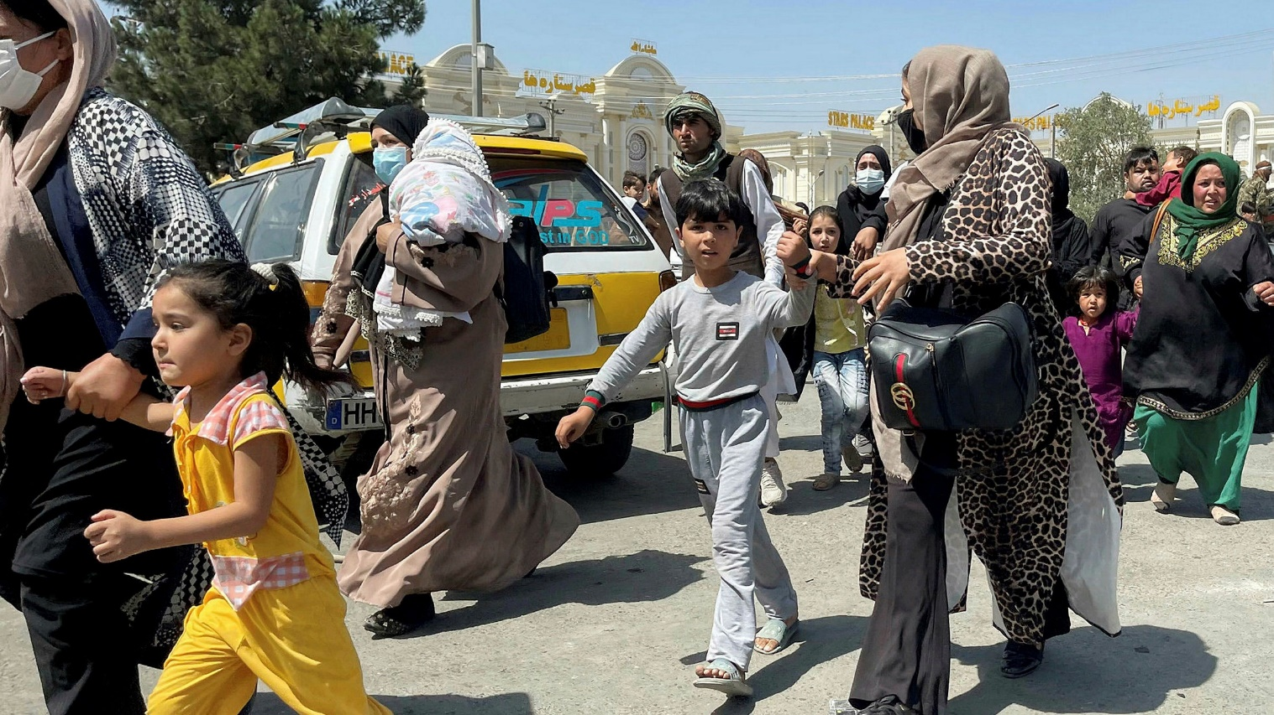

Included in this kit is the information you need to create your own letters or use the proformas

- Guide and Background notes prepared by ARAN’s Letter Writing Network.
- 2 proforma letters that you can copy (and personalise) to send by post or email.
- Postal Addresses for MPs and Senators
- Email addresses for MPs and Senators

Personalised letters are best –

- You might like to use the AIDA principle

  - A - Attention - grab the recipient's attention. Say something positive about the reader that is directed towards the focus of your letter. Stimulate the recipient's curiosity

  - I - Interest&Information- encourage the recipient to read on.

  - D - Desire - Getting the reader to want to do what you are seeking - in their interest to do so.

  - A - Action- inform the reader of the action you want them to take.

~~~~~~~~~~~~~~~~~~~~~~~~~~~~~~~~~~~~~
Regards,
The ARAN Letter Writing Network
austrefugeenetwork@gmail.com

BACKGROUND INFORMATION FOR Increase the Afghan refugee intake to at least 20,000

Choose 2 or 3 dot points to use in your letter.
Paraphrase these using your own words.

- The Morrison government is offering 3,000 places for Afghan refugees from within Australia’s existing allocation in the humanitarian intake program.

- By mid-October 2021, more than 100,000 Afghan nationals were vying for the initial 3,000 humanitarian visas from Australia.https://www.sbs.com.au/news/more-than-100-000-afghans-apply-for-australian-humanitarian-visas/defc7e00-e72b-4ab9-8a94-5212a1424a95

- What is needed is an immediate substantial additional allocation of places for refugees from Afghanistan. The UK has pledged 20,000 places, while Canada has pledged 40,000 places for refugees from Afghanistan. Australia should at least match that those offers. The USA has set a 35,000 cap for the Near East/South Asia region

- Since the Taliban took control of Afghanistan, many people there are in grave danger - people who have worked with Australian and other western governments and organisations, women and girls, and members of religious and ethnic minorities such as the Hazaras.

- Violent attacks, and forced marriages of young women and girls have been reported.

- There is much internal displacement in Afghanistan as people flee for their lives trying to escape the Taliban. Many people are experiencing hunger and homelessness.

- Afghans in Australia hold grave fears for the safety of their family members remaining in Afghanistan.

- The Australian community has demonstrated its strong support for a more generous response to people fleeing Afghanistan. The resettlement of a special intake of refugees is well within the capability of Australia’s community sector, the Afghan-Australian community and the wider community. https://www.theguardian.com/australia-news/2021/aug/31/residual-trauma-of-afghan-refugees-fleeing-taliban-will-be-among-highest-levels-australia-has-resettled

- The Department of Home Affairs’ annual report revealed that in 2020-2021, while the Australian Government filled its Migration Program quota, it issued fewer than half of the available refugee and humanitarian visas.

Australia’s 2020-21 Refugee and Humanitarian Program was the smallest in 45 years, with only 5947 visas issued out of the already reduced annual program of 13,750 places.

“Over the past four years, we have seen the number of refugee and humanitarian visas issued fall from of its 35-year high of 21,698 in 2016-17 [under Malcolm Turnbull] to little more than a quarter of that in 2020-21,” Refugee Council of Australia chief executive officer PaulPower said.

- Dept of Foreign Affairs and Trade has revealed that, despite a long-term campaign by former ADF personnel, the government only began drafting plans to actively help former interpreters and security guards escape Afghanistan after former prime minister John Howard joined the call for action in July.
https://www.thesaturdaypaper.com.au/news/politics/2021/11/13/australia-allow-visas-trapped-afghans-expire/163672200012866

Key requests

- Increase the Afghan refugee intake to 20,000
or
- Match the Canadian offer of 40,000 places
and
- Grant permanent protection to refugees from Afghanistan

Addresses for your letters:

- The Prime Minister
Prime Minister
PO Box 6022,
House of Representatives,
Parliament House,
Canberra ACT 2600

You cannot email the PM. Use the following link to the PM’s Contact Form.
https://www.pm.gov.au/contact-your-pm

- Alex Hawke Minister for Immigration
The Hon Alex Hawke,
Minister for Immigration, Citizenship, Migrant Services & Multicultural Affairs
PO Box 1173,
Castle Hill
NSW 1765

Use the following link to the Contact Form for Alex Hawke:https://www.aph.gov.au/Senators_and_Members/Contact_Senator_or_Member?MPID=HWO

- The Hon Karen Andrews Minister for Home Affairs
The Hon Karen Andrews
Minister for Home Affairs
PO Box 409,
Varsity Lakes
QLD 4227
Email: Karen.Andrews.MP@aph.gov.au

You may also like to send emails to:

- Shadow Minister of Home Affairs Kristina Keneally senator.keneally@aph.gov.au
- Greens Senator Nick McKim senator.mckim@aph.gov.au

Canberra Postal Address for all Senators
PO Box 6100
Senate,
Parliament House
Canberra ACT 2600
Canberra Postal Address for all MPs
PO Box 6022
House of Representatives
Parliament House
Canberra ACT 2600

Find electorate postal and email addresses for your local MP:https://www.aph.gov.au/senators_and_members/members

Email addresses for MPs and Senators - https://aran.net.au/resources/letter-writing/
Email addresses for all Senators are on the next page

CAPITAL CITY NEWSPAPERS Email links for Letters to Editor
Sydney Morning Herald letters@smh.com.au
Melbourne Age letters@theage.com.au
Herald Sun (Melbourne) https://www.heraldsun.com.au/news/opinion/letter-to-the-editor
Courier Mail (Brisbane) https://www.heraldsun.com.au/news/opinion/letter-to-the-editor
Canberra Times https://www.canberratimes.com.au/comment/send-a-letter-to-the-editor/
The Advertiser (Adelaide) https://www.canberratimes.com.au/comment/send-a-letter-to-the-editor/
The Mercury (Hobart) https://www.themercury.com.au/news/opinion/letter-to-the-editor
NT News https://www.themercury.com.au/news/opinion/letter-to-the-editor
West Australian letters@wanews.com.au.

Email addresses for all Senators - 12 Nov 2021

Email addresses for allACTsenators - ready to copy and paste into “TO” section of your email:
senator.katy.gallagher@aph.gov.au; senator.seselja@aph.gov.au

Email addresses for allNSW senators - ready to copy and paste into “TO” section of your email:
senator.ayres@aph.gov.au; senator.bragg@aph.gov.au;senator.davey@aph.gov.au;
senator.faruqi@aph.gov.au; senator.fierravanti-wells@aph.gov.au; senator.hughes@aph.gov.au;
senator.keneally@aph.gov.au; senator.mcallister@aph.gov.au; senator.molan@aph.gov.au;
senator.oneill@aph.gov.au; senator.payne@aph.gov.au; senator.sheldon@aph.gov.au;

Email addresses for allNTsenators - ready to copy and paste into “TO” section of your email:
Senator.McCarthy@aph.gov.au; senator.mcmahon@aph.gov.au

Email addresses for allQueenslandsenators - ready to copy and paste into “TO” section of your email:
senator.canavan@aph.gov.au;senator.chisholm@aph.gov.au; senator.green@aph.gov.au;
senator.hanson@aph.gov.au;senator.mcdonald@aph.gov.au;senator.mcgrath@aph.gov.au;
senator.rennick@aph.gov.au;senator.roberts@aph.gov.au; senator.scarr@aph.gov.au;
senator.stoker@aph.gov.au;senator.waters@aph.gov.au;senator.watt@aph.gov.au;

Email addresses for allSAsenators - ready to copy and paste into “TO” section of your email:
senator.antic@aph.gov.au;senator.birmingham@aph.gov.au;senator.farrell@aph.gov.au;
senator.fawcett@aph.gov.au;senator.griff@aph.gov.au;senator.grogan@aph.gov.au;
senator.hanson-young@aph.gov.au;senator.mclachlan@aph.gov.au; senator.patrick@aph.gov.au;
senator.ruston@aph.gov.au;senator.marielle.smith@aph.gov.au;senator.wong@aph.gov.au;

Email addresses for allTasmaniasenators - ready to copy and paste into “TO” section of your email:
senator.abetz@aph.gov.au;senator.askew@aph.gov.au;senator.bilyk@aph.gov.au;
senator.carol.brown@aph.gov.au;senator.chandler@aph.gov.au;senator.colbeck@aph.gov.au;
senator.duniam@aph.gov.au; senator.lambie@aph.gov.au; senator.mckim@aph.gov.au;
senator.polley@aph.gov.au;senator.urquhart@aph.gov.au; senator.whish-wilson@aph.gov.au;

Email addresses for allVictorian senators - ready to copy and paste into “TO” section of your email:
senator.carr@aph.gov.au; senator.ciccone@aph.gov.au; senator.henderson@aph.gov.au; senator.hume@aph.gov.au;senator.kitching@aph.gov.au;senator.mckenzie@aph.gov.au;
senator.paterson@aph.gov.au;senator.rice@aph.gov.au; senator.thorpe@aph.gov.au;
senator.walsh@aph.gov.au; senator.van@aph.gov.au;

Email addresses for allWAsenators - ready to copy and paste into “TO” section of your email:
senator.brockman@aph.gov.au; senator.cash@aph.gov.au; senator.cox@aph.gov.au
senator.dodson@aph.gov.au; senator.lines@aph.gov.au; senator.matt.o'sullivan@aph.gov.au; senator.pratt@aph.gov.au; senator.reynolds@aph.gov.au; senator.small@aph.gov.au;
senator.smith@aph.gov.au; senator.steele-john@aph.gov.au; senator.sterle@aph.gov.au

NOTE: If you are sending an email be sure to include your NAME and ADDRESS
Email addresses for MPs and Senators - https://aran.net.au/resources/letter-writing/

The Subject line of your email could be -
CALL TO ACTION Increase the Afghan refugee intake to 20,000

PROFORMA LETTERS - Increase the Afghan refugee intake to 20,000

LETTER 1. The Hon Karen Andrews Minister for Home Affairs

The Hon Karen Andrews
Minister for Home Affairs
PO Box 409
Varsity Lakes QLD 4227

Dear Minister

It is time for the Australia Government to step up and offer substantially more humanitarian places to people fleeing Afghanistan.

According the Department of Home Affairs, by mid-October, more than 100,000 Afghan nationals were vying for the initial 3,000 humanitarian visas allocated by theGovernment.

Speaking before the Senate committee into Australia's involvement in Afghanistan, Department of Home Affairs official David Wilden described the inundation of visa requests witnessed in recent weeks.

“We have 26,000 applications which is well in excess of 100,000 people applying,” he told the committee.

According to David Wilden, most applications have multiple people attached to them - usually close family members.

I ask that the Government -

- Immediately increases the Afghan humanitarian refugee intake to at least 20,000 places.
- Or better still, matches the Canadian offer of 40,000 places.

I also ask that the Government grants permanent protection to refugees from Afghanistan, whether they are new arrivals or have been in Australia prior to the recent fall of Kabul.

Yours sincerely

Name:
Address:

Reference:
SBS News. More than 100,000 Afghans apply for Australian humanitarian visas. 11 Oct 2021
https://www.sbs.com.au/news/more-than-100-000-afghans-apply-for-australian-humanitarian-visas/defc7e00-e72b-4ab9-8a94-5212a1424a95

LETTER 2. The Hon Alex Hawke, Minister for Immigration

The Hon Alex Hawke,
Minister for Immigration, Citizenship, Migrant Services & Multicultural Affairs
PO Box 1173,
Castle Hill
NSW 1765

Dear Minister

It is time for the Australia Government to step up and offer substantially more humanitarian places to people fleeing Afghanistan.

According the Department of Home Affairs, by mid-October, more than 100,000 Afghan nationals were vying for the initial 3,000 humanitarian visas allocated by theGovernment.

Speaking before the Senate committee into Australia's involvement in Afghanistan, Department of Home Affairs official David Wilden described the inundation of visa requests witnessed in recent weeks.

“We have 26,000 applications which is well in excess of 100,000 people applying,” he told the committee.

According to David Wilden, most applications have multiple people attached to them - usually close family members.

I ask that the Government -

- Immediately increases the Afghan humanitarian refugee intake to at least 20,000 places.
- Or better still, matches the Canadian offer of 40,000 places.

I also ask that the Government grants permanent protection to refugees from Afghanistan, whether they are new arrivals or have been in Australia prior to the recent fall of Kabul.

Yours sincerely

Name:
Address:

Reference:
SBS News. More than 100,000 Afghans apply for Australian humanitarian visas. 11 Oct 2021
https://www.sbs.com.au/news/more-than-100-000-afghans-apply-for-australian-humanitarian-visas/defc7e00-e72b-4ab9-8a94-5212a1424a95

LETTER 3. Your local MP

……………………………. [Fill in your local MP’s name]
Member for ….

Dear ………….

I have just written to the Minister for Home Affairs and the Minister for Immigration, regarding the urgent need for the Australian Government to offer substantially more humanitarian places to people fleeing Afghanistan than the initial 3,000 places.

You may not be aware that the Department of Home Affairs has already received visa applications representing approximately 100,000 people.

This means that we are currently offering only ONE place for every 30 people who have applied.

Many Australian cities and towns already have Afghan communities, where people have adjusted well to Australian life and are making a very real contribution to their new homeland.

Please find copies of my letters to Ministers Andrews and Hawke attached.

Yours sincerely

Name:
Address:

Reference:
SBS News. More than 100,000 Afghans apply for Australian humanitarian visas. 11 Oct 2021
https://www.sbs.com.au/news/more-than-100-000-afghans-apply-for-australian-humanitarian-visas/defc7e00-e72b-4ab9-8a94-5212a1424a95

LETTER 4. Letter to the Editor

Dear Editor

I have just written to the Ministers for Home Affairs, and Immigration, regarding the urgent need for ourgovernment to offer more than 3,000 humanitarian places to people fleeing Afghanistan.

We are currently offering just ONE place for every 30 people who applyfor protection in Australia.

Under the Taliban people are being forced from their homes, from their land. For people who previously worked with the Australia governments as interpreters, etc., life has become extremely dangerous. And for women and girls,it is truly terrifying as they are forced into marriages with Taliban soldiers.

Many Australian cities and towns already have well-established Afghan communities, where people have adjusted happily to Australian life and are making a very real contribution to their new homeland.

I ask all Australians to support this call to government for more places for Afghan refugees.

For more information: [include contact details of your local refugee group/organisation]

Name:

Address:
Phone:

